Business Requirements Document

for CRM PORTAL

Table of Contents

1. Executive Summary

2. Business Objectives

3. Background

4. Scope

5. Functional requirements

1**. Executive Summary**

We are looking to set up a portal/website that will tie into our current Dynamics 365 CRM. We

want to provide a high level of customer service to our applicants. **The goal is to make our process**

**clear, concise, and accessible to them so that they have more control over their progress.** To

achieve this, we are looking for user capability that allows them to perform searches, track

progress, identify and complete assignments, download and submit required docs,

submit/update account information, and view a calendar of events for webinars and trainings.

This should also be an avenue that our coaches can assign customer specific training

requirements and track their engagement and completion. We want to include all departments,

even ones that have not been included in previous solutions (IT, HR, Finance), in the process.

2. **Business Objectives**

The main objectives for this website are team search, progress tracking, clear delivery of our

business process, and ‘candidate school’ registration & homework/forums. We would also like to

allow users to submit and update contact information. This will allow us to keep cleaner and

more “real‐time” data within our CRM and user profiles. This will also allow coaches to closely

monitor the individuals that have been assigned training to ensure that they have been

completed. It will also allow the customers/users to be able to sign up for events and receive

promo codes that can be used for webinars and training sessions.

3. **Background**

In the past, we’ve offered similar functionality to our contacts preparing for the field

(journeyers/applicants/candidates/appointees) as a standalone web site. The site’s platform

became obsolete and is now offline. It required staff to double‐enter interactions with contacts

in the site and CRM, and contacts found it difficult to navigate. We currently offer a reduced scope

site to temporarily fill our Candidate School attendees’ needs to register and complete

event pre‐work, employing 3rd‐party data collection via Formstack.

Our goal is to learn from and improve on past efforts by giving applicants direct (though

limited/controlled) access to CRM data and staff in a format using current technology and

best‐practice user experience design.

4. **Scope**

• Main portal theming and specific theming for each page

• Main page/splash page with links

• Opportunity page

o Process bar

o Area to edit contact info

o Sub‐grid for coaching items

o Sub‐grid for membership teams

o Area to submit forms

• Overlay ‘pop out’ page to edit coaching Items

• Team search with filters

• Team result detail

o Needs to look read‐only with a button that submits one field containing the Contact

ID so a membership team record can get created via some backend process

• Blank forms list page (this could be part of the opportunity page)

• Unauthenticated outward facing form for initial application (may or may not iFrame

Formstack form)

• Main form with signature (current plan is to iFrame Formstack form)

• Homework items will either direct to the forums or use a grid on the opportunity, which

would need a ‘pop‐out’ page

• Process to provision portal user based on button press on opportunity

• Multiple portal security roles based on specific entity permissions which will need to be

created

• Process to change a user’s security role/entity permissions depending on where they are

in the process

• Custom business process flow for the opportunity page in the portal

• Structured process for downloading blank forms

• Structured process for uploading completed forms

• Navigation structure

5. **Functional requirements**

Please note that people in our “pipeline” – those who have filled out a Journey form, those who have

submitted a Long Term Application (LTA), those whose LTAs have been approved and are eligible for

Candidate School (CS), those who have completed CS but have not yet found a team, and those who

have been appointed to a team – are all referred to below as Pipeline Portal “users”. Pipeline Portal

users who are on staff are referred to as “staff”.

**A Priorities**

5.1 Contact Login Portal

5.2 Track Progress and Submit Forms

5.3 Register / Complete CS Homework

5.4 Team Search

**B Priorities**

5.5 Update basic contact info

5.6 Event/Training Promotions

5.7 Coaching/Development Tracking

5.8 Regional Promotions

**C Priorities**

5.9 Payment Portal

5.10 Expanded Team Search

5.11 Skills/Knowledge Courses (LMS)

5.12 PDM Tracking

**A Priorities: Detailed Requirements**

*5.1 Contact Login Portal*

The first page presented to the user will include these features/functions:

• Fields for entering a username and password

• A link that leads user to a sequence for recovering username and resetting password

• Ability for portal admin to modify theme background graphics, fonts, placement of elements

• Ability to add generic featured content to a pre‐login audience, if we choose to

• Design with single‐sign‐in capability in mind

As an example (for illustration purposes, not to specify an end result), here is a login page for a site

we’re using as a temporary fill‐in for this project:

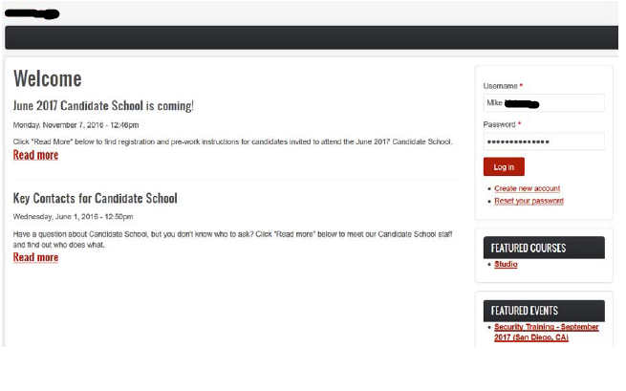

*5.2 Track Progress and Submit Forms*

A key goal for this portal is to allow users and staff to share information in real time. We envision that

users will see a page specifically laid out for their use. Staff members will have access to the page seen

by users, but they will do most of their information sharing and viewing in their accustomed screens in

our Office365 Dynamics CRM (Contacts, Opportunities, etc.).

Functions and features needed:

**Track Progress:**

• A dashboard‐like page/screen highlighting users completed, in‐progress, and future “to

do” items in preparing for the field (“Progress Dashboard”)

• At the top of the Progress Dashboard, an overall graphic visualization of the Pipeline

stages and where the user sits in relation to them. For example, similar to the CRM’s

current display, user sees a series of arrow blocks with Journeyer ‐> Applicant ‐>

Candidate ‐> CS Graduate ‐> Appointee.

• A display of the user’s **current** single‐point‐of‐contact, based on CRM data. Users have

single‐point‐of‐contact staff members assigned to them as coaches. The assignment

changes, as users progress, from Rep (initially) to Prep Coach (after

LTA is approved) to Coach (when user is on field).

• Display of preparation activities: Completed, In Progress, Scheduled, with status

displayed for each item. User can add activities as Scheduled, both ad hoc and from a

list of CRM Coaching Opportunities. User can update activities as “In Progress” or

“Completed”. Coach is notified of changes made by user.

• Display of next scheduled meeting between user and coach, from CRM data

• A block on the Progress Dashboard for links to resources assigned by coach, referred to

in user’s list of prep activities; ability for coach to post such resources from within

his/her commonly‐used CRM display, generating the link on user’s Progress Dashboard

**Submit Forms:**

Users will encounter a variety of forms in moving through the Pipeline. To make the exchange of

information more efficient, coaches and users will need:

• A secure, user‐friendly way to collect data from users and upload it into

corresponding fields in the CRM in an automated way, either in real time (preferred)

or in batches. Current practice involves creating forms in an external app (e.g.

Formstack).

• The ability for each form to pull data fields from the CRM database, where such data

are available, to pre‐load data into those fields in a form the user fills out. User will

then review and edit the existing data as needed instead of re‐entering it.

• Form design and submittal that allows for and anticipates the use of electronic

signatures to record user acceptance of the content of a form.

A rough mock‐up, below, includes many of these features:

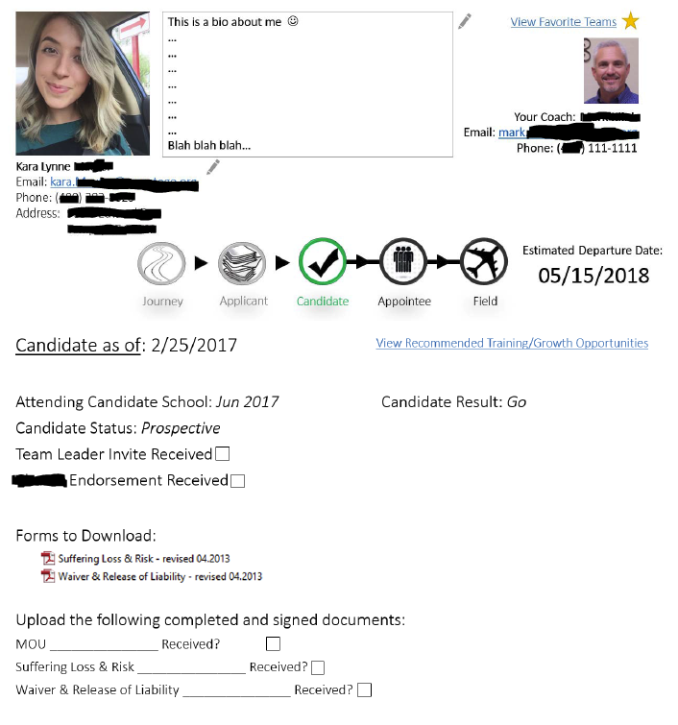

8

*5.3 Register / Complete CS Homework*

A key point of interaction between user and coach is a two‐week event, Candidate School (CS). The CS

event is used to orient users to our organization, introduce a series of important preparation topics, and

assess users’ readiness to look for a field team. Webforms contained within an internally‐owned web

site have been used to gather registration data for CS (Personal Data for each adult, Kids Camp data on

children and their development, and Travel Plans). An external site has been used to collect payment.

Once registration data and initial payment have been received, candidates are given a series of pre‐work

assignments to be completed. Pre‐work content (readings, videos, online forum postings) has also

resided within an internal website.

Functions and features needed by users and staff:

• (General needs for online forms were discussed in Section 5.2 under “Submit Forms”.)

For CS, create the forms for Personal Data, Kids Kamp, and Travel Plans. Form fields

containing data that already exist in the CRM will be linked and pre‐populated for user

to review and update; fields unique to CS will be created in the CRM to receive the new

data.

• Offer CS pre‐work tasks and content items to users in a structure that allows user and

coach to see the full list of tasks and status (Scheduled, In Progress, Completed with

date info).

• Provide for user download of documents, e.g., PDF or Word files, viewing of audio/video

content, and staff/site admin upload of that content to the CRM. Provide for user to

upload an edited version of a downloaded document, e.g. Word file.

• Provide a forum/discussion space for CS candidates and staff to post questions (staff)

and answers (candidates) and interact with one another’s posts. Can roll up a forum

discussion and export it to another application, e.g. Word or Excel.

• Display registration status to user and coach/staff based on completion of the three

registration forms and receipt of initial payment. Configure registration status field so

that it can be rolled up as a report on all CS attendees’ status for staff to review.

• Design registration status tracking to be easily integrated with an external payment

application as a future project phase (see Section 5.9, “CS Payment Portal”, for details).

*5.4 Team Search*

Users who are not already members of a ‘group team’ applying need to find and join a team (“Appointed” status)

before raising funds to leave for the field. The process of finding a team is currently somewhat

unstructured. A goal of this Pipeline Portal is to provide some structure, enabling users and staff to

work together and find user‐team matches more efficiently.

Features and functions needed for team search:

• Team search is dependent on a user’s pipeline status. The ability to look for potential

team fits is not applicable until the Journey interview is completed. Team search

features on a user’s Progress Dashboard will not be visible until approval is registered

(e.g., “Ready to Explore Teams”) in the CRM.

• Users will only be able to view/search teams that currently indicate that they are

looking for or are open to new members.

• Team search will make use of key team attributes (see mock‐up below for examples) to

allow approved users to run searches. Likely matches will be displayed on user’s

Progress Dashboard (or separate search page).

• A user’s identification of a likely match will trigger a notification to his/her Opportunity

Owner. The Owner will be able to view user’s likely matches within his/her normally

viewed CRM screens.

• Likely matches will have status information displayed (e.g., Contact Pending,

Contacted/Potential Match, Contacted/Not a Match) with dates and comment fields as

appropriate.

• Users will not have direct access to a team’s contact information. The Owner,

responding to the notification that user has posted a likely match, will help user

determine the match’s viability and pass contact info to the user if appropriate.

**B Priorities: Detailed Requirements**

*5.5 Update Basic Contact Info*

• On the Progress Dashboard, include a display of the user’s contact information (name,

address, phone, etc.). An example is shown in the mock‐up screen above, under the

user’s photograph.

• Contact information, including photo, is editable by the user. When user makes a

change, a notification to the user’s current coach is generated.

*5.6 Event / Training Promotions*

In addition to listing coaching and development events as individual items in the Coaching /

Development section of the CRM and on users’ and coaches’ individual displays, we will need the ability

to highlight them on the portal’s first‐seen page. More details will then be available by clicking on an

event’s promo on the front page or by finding it in a dropdown list on the main site menu. Both actions

will lead to a dedicated page for that event.

Functions/features:

• Events will have “effective date/time” characteristics. Events that expire are no longer

displayed

• Notification of an event’s pending expiration (1 week? 1 day?) is sent to the person who

posted the event.13

• Link on the event’s page to a registration form, either a CRM‐hosted webform or an

external (e.g. Formstack) resources

• Recording in the CRM of a user’s registration for an event in his “to do” list; notification

to coach of a user’s having registered

An example from our current temporary site:

*5.7 Coaching / Development Tracking*

The pipeline process can provide opportunities for a user to take advantage of coaching and

development resources that will ease the transition from home to field and allow the user to be

effective on field more quickly.

This project will provide a structure that will make it easier for user and coach to take advantage of

specific opportunities that fit the user’s prior experience, education, and his/her anticipated role on the

field:

• User and coach can view a list of resources (currently captured in the CRM as Coaching

Opportunities) and add them to a coaching/development‐specific “to do” list (called

“Training Timeline” here) in the user’s Progress Dashboard (or sub‐screen).

• If user adds a resource to his/her Training Timeline (TT), coach(es) receive notification.

(More than one coach may be on the notification list.)

• If coach adds to the TT, user receives notification

• Coaching Opportunities may be internal (hosted/run/created by USSB staff) or external

• Status of each item on the TT is tracked (e.g., Scheduled, Completed/date)

• Fields associated with coaching and development and the TT will allow staff to roll up a

report of individual user activity/item status and of users who take advantage of

individual resources.

• Ideally, this section will be designed to allow extension in a future phase to either

internally mimic the functions of a Learning Management System (LMS) or connect to an

existing 3rd party LMS via API (see Section 5.12, “Skills/Knowledge Courses (LMS)”, for

details).

*5.8 Regional Promotions*

One of our key organization goals is to increase users’ awareness of the full global scope of

opportunities to serve, and to offer insight into key target regions.

Examples of portal features to aid in promoting regional opportunities:

• Dedicate a block on user’s Progress Dashboard to display a graphic/teaser text for a

specific region opportunity, with link to a page containing more details

• Detail page, linked to from promo block. Page is based on a template, designed to allow

a staff member to plug in images, content (text, audio, video), contact info/”like”

feedback from user

• Notification sent to user’s Opportunity Owner and regional promo owner if user clicks

on a feedback link; interest recorded in CRM

• Ability to manage regional promos’ timeliness in a manner similar to event promos (see

Section 5.6) with expiration date and reminder of expiration sent to owner

**C Priorities: Detailed Requirements**

*5.9 Payment Portal*

Users occasionally need to make financial payments to the organization for training events, candidate

assessment, and background checks. Perhaps the most significant single milestone in a user’s

preparation for the field is to attend the two‐week Candidate School (CS) event. The offering of a CS

event involves significant expense that’s partially underwritten by our organization, with attendees

paying for the remainder. The formula for calculating each attendee’s fee is complex. This complexity

eliminates most 3rd‐party payment sites (e.g. event ticketing apps like Eventbrite) from consideration as

a solution. Factors in determining CS fees may include:

• Single adult / couple / couple with children

• Need for Week 1 housing (vs local, or locally‐hosted, attendee)

• Member of Group Team, joining mid‐event

• Attendee of pre‐CS event, e.g., Seminar(s)

Allowance for multiple payment flexibility is another factor that makes it difficult to find 3rd party apps

that can fulfill our need:

• All attendees must submit an initial deposit to be considered “registered” for CS

• Attendees can then make follow‐on payments as desired until they’ve paid their balance

• In some cases, attendees’ payments may extend beyond the end of the CS event

*5.10 Expanded Team Search*

Section 5.5 described a limited set of Team Search features and functions designed to allow users to

look for prospective teams under the guidance of their assigned Opportunity Owner.

As a next step in Team Search functionality, Team Leaders (TLs) of teams looking for new Team

Members (TMs) will be able to search for TMs through the Pipeline Portal. As with a user’s search for a

team, the user’s coach continues to play a pivotal role in connecting user and team.

• TLs will be able to pull up a display/report of users who are ready to join a team (a CRM

field described in Section 5.4) but have not yet joined one

• Display of prospective TMs will show, and allow filtering/sorting on, key attributes (e.g.

single/married, region/people group of interest, occupation, languages acquired)

• Clicking on an individual user in the display will lead to that user’s Contact information

in the CRM (could be all fields or selected fields).

• If TL wishes to contact an individual user in the list about an opportunity, request is

logged in the CRM and notification of request goes to user’s coach. When coach

acknowledges the notification, TL’s request to connect appears prominently on user’s

Progress Dashboard

Note that, as most TLs employing this feature will be located abroad, our IT staff will work with this project’s developers to employ best practices in this area.

*5.11 Skills / Knowledge Courses (LMS)*

In Section 5.7, basic features and functions are described for tracking a user’s progress in preparing for

the field. As we gain insight on the most important areas of focus in preparing users, add to our catalog

of training opportunities, and develop content ourselves, we will want to have a more formal Learning

Management System (LMS) structure. Format would emulate a typical portal used by an online

university student (our users) and faculty (our staff):

• Staff postings for users, e.g., assignments, course content, curricula

• Forum space for staff to post discussion questions and for users to respond to staff and

to one another

• Links to web conference resources for real‐time online presentation of content (web

conferencing is assumed to be a 3rd party provider, e.g, Zoom)16

• Ability to record presentations for offline/asynchronous learning

• Course/lesson structure for each learning opportunity

• Course catalog / curriculum structure to organize the full set of learning opportunities

into logical groups and sequences

• Ability for user and coach to customize a default curriculum to meet the needs of

individual users

Implementation may employ an existing LMS platform and developing an interface between it and our

CRM (or finding an LMS platform that has already built an API for Microsoft Dynamics). If no feasible 3rd

party LMS platform is available, we will develop similar features and functions within the current Dynamics portal platform’s capabilities.

*5.12 PDM Tracking*

A key indicator of readiness for the field is financial – how close an appointee to a team is to being fully

funded, and the appointee’s rate of progress toward that goal.

A separate project within our organization is employing a platform to give users an updated online

ability to manage their support raising activities. When that new platform is complete and stable, we

will want to explore the development of an interface between this Pipeline Portal and the platform to

allow users and their coaches to review funding status from within the Pipeline Portal. Data fields may

include (as examples) current funding total in $$, funding goal in $$, percent raised, and funding $$/%

by month over the last 6 months.